Project report on

**Smart Vehicle Telematics** **System using CAN**

Guided by

**Mr. Ankush Tembhurnikar**

Presented by:

**Prajakta Chavan 240844230017**

**Divya Salunke 240844230023**

**Akshita Vyas 240844230004**

**Vidhi Shende 240844230077**

At

**Sunbeam Institute Of Information Technology,**

**Hinjawadi**. **Pune**

**SUNBEAM INSTITUTE OF INFORMATION TECHNOLOGY, HINJAWADI.**



This is to certify that the project

Smart Vehicle Telematics System using CAN

Has been submitted by

**Prajakta Chavan 240844230017**

**Divya Salunke 240844230023**

**Akshita Vyas 240844230004**

**Vidhi Shende 240844230077**

In partial fulfillment of the requirement for the course of **PG Diploma In**

**Embedded System Design (PG-DESD AUG-2024)** as prescribed by the

**CDAC** ACTS, PUNE.

Place : Hinjawadi Date : 12-02-2025

**ACKNOWLEDGEMENT**

This project “ **Smart Vehicle Telematics System using CAN** ” was a great learning experience for us and we are submitting this work to SUNBEAM (CDAC).

We all are very glad to mention the name of *Mr.Ankush Tembhurnikar* for his valuable guidance to work on this project. His guidance and support helped us to overcome various obstacles and intricacies during the course of project work.

Our most heartfelt thanks goes to *Mr. Sohail Inamdar* (Course Coordinator, PG-*DESD*) who gave all the required support and kind coordination to provide all the necessities like required hardware, internet facility and extra Lab hours to complete the project and throughout the course up to the last day here in C-DAC SUNBEAM, Pune.

**ABSTRACT**

This system is an attempt to analyze a driver alert system. The implementation uses a Controller Area Network (CAN) integrated with the STM32F407 microcontroller for communication between two nodes. CAN is one of the most versatile and widely used technologies in the electronics industry, finding applications in automotive and industrial sectors.

The Controller Area Network (CAN) is a serial, asynchronous, multi-master communication protocol used for connecting electronic devices and control modules. It is designed for automotive applications that require high data integrity and supports data rates of up to 1 Mbit/sec.

The project flow consists of continuous monitoring of sensor values, including a temperature sensor (LM35), an ultrasonic sensor, and an MQ-3 gas sensor. These sensors are interfaced with the microcontroller for real-time data acquisition. The system functions as follows:

* Temperature Sensor (LM35): If the temperature rises above 60°C, an alert is triggered.
* Ultrasonic Sensor: Measures the distance between the obstacle and the vehicle. If an obstacle is detected nearby, the distance is displayed on an LCD.
* MQ-3 Gas Sensor: This sensor is used to detect alcohol concentration in the driver's breath. If the alcohol level crosses a defined threshold, an alert is triggered.

The collected data (temperature, distance, and alcohol concentration) is continuously displayed on an LCD. If any of these values exceed a predefined limit, a buzzer is activated to alert the driver.

**TABLE OF INDEX**

**Topic Page No.**

0. Introduction 6

1. Literature Survey 7

1. ARM Cortex M4 Architecture 7

2. Controller Area Network 8

1. CAN Network 8

2. CAN Bus 8

3. CAN Bus Levels 9

4.CAN Frames 10

5. Bus Arbitration 12

3. Requirements 14

3.1 Hardware Requirements 14

1 Introduction to STM32F407 Discovery Board 14

2 CAN Transceiver 17

3.2. Software Requirements 19

1 STM32CubeIDE 19

4. Project Architecture and Flow Chart 21

4.1 Block Diagram 21

4.2 Description 21

4.3 Flow Chart 23

5. Source code explanation 24

5.1 Transmitting node source code 24

5.2 Receiver node source code 26

6. Testing 28

7. Conclusion and Future Scope 31

8. References 32

**1] Introduction**

This system helps in achieving effective communication between transmitter and receiver modules using CAN protocol with multiple sensors to monitor the various parameters and visualize them to the vehicle driver through a LCD display .The CAN modules interfaced with the sensors for this system are temperature sensor capable of detecting engine heat, ultrasonic sensor for detecting the distance between obstacles. This is important that human drivers control over the vehicle and check the parameters in vehicle on LCD screen at the same time of driving, parameters like engine temperature and obstacle’s distance. CAN protocol (bus) are used for data transmission. A CPU is needed to manage the CAN protocol. The STM32F407 microcontroller is used as the CPU that can manage bus arbitration, assigning priority for the message addressing and identification. For the CAN bus– based designs it is easier to use a STM32F407 microcontroller with a built-in CAN module, such devices include built-in CAN controller hardware on the chip. For implementation of this digital circuitry need a different component the main part for controlling all information to check working for this purpose use a processor for the sensing purpose use a temperature sensor, obstacle detection sensor and power supply are main parts.

**1] Literature survey**

1] ARM- CORTEX M4 Architecture



Fig. 1.1 ARM CORTEX M4 Architecture

The ARM cortex-M4 processor is a high performance embedded processor with DSP instructions developed to address digital signal control markets that demand an efficient , easy-to-use blend of control and signal processing capabilities. The processor is highly configurable enabling a wide range of implementation from those requiring floating point operations, memory protection and powerful trace technology to cost sensitive devices requiring minimal area.

Key benefits:

1. Gain the advantages of a microcontroller with integrated DSP, SIMD, and MAC instructions that simplify overall system design, software development and debug

2. Accelerate single precision floating point math operations up to 10x over the equivalent integer software library with the optional floating point unit (FPU)

3. Develop solutions for a large variety of markets with a full-featured ARMv7-M instruction set that has been proven across a broad set of embedded applications

4. Achieve exceptional 32-bit performance with low dynamic power, delivering leading system energy efficiency due to integrated software controlled sleep modes, extensive clock gating and optional state retention.

**2] Controller Area Network**

The Controller Area Network bus, or CAN bus, is a vehicle bus standard designed to allow devices and microcontrollers to communicate with each other within a vehicle without a host computer.

CAN is a reliable, real-time protocol that implements a multicast, data-push, publisher /subscriber model. CAN messages are short (data payloads are a maximum of 8 bytes, headers are 11 or 29 bits), so there is no centralized master or hub to be a single point of failure and it is flexible in size. Its real-time features include deterministic message delivery time and global priority through the use of prioritized message IDs.



Fig. 2.1 CAN network

**2] CAN Bus**



Fig .2.2 . CAN Bus

Physical signal transmission in a CAN network is based on transmission of differential voltages **(differential signal transmission**). This effectively eliminates the negative effects of interference voltages induced by motors, ignition systems and switch contacts. Consequently, the transmission medium (CAN bus) consists of two lines: CAN High and CAN Low. Physical signal transmission in a CAN network is based on transmission of differential voltages **(differential signal transmission**). This effectively eliminates the negative effects of interference voltages induced by motors, ignition systems and switch contacts. Consequently, the transmission medium (CAN bus) consists of two lines: CAN High and CAN Low.

Twisting of the two lines reduces the magnetic field considerably. Therefore, in practice twisted pair conductors are generally used as the physical transmission medium. Due to finite signal propagation speed, the effects of transient phenomena (**reflections**) grow with increasing data rate and bus extension. Terminating the ends of the communication channel using **termination resistors** (simulation of the electrical properties of the transmission medium) prevents reflections in a high-speed CAN network.

Twisting of the two lines reduces the magnetic field considerably. Therefore, in practice twisted pair conductors are generally used as the physical transmission medium. Due to finite signal propagation speed, the effects of transient phenomena (**reflections**) grow with increasing data rate and bus extension. Terminating the ends of the communication channel using **termination resistors** (simulation of the electrical properties of the transmission medium) prevents reflections in a high-speed CAN network.

The key parameter for the bus termination resistor is the so-called characteristic impedance of the electrical line. This is 120 Ohm. In contrast to ISO 11898-2, ISO 11898-3 (low-speed CAN) does not specify any bus termination resistors due to the low maximum data rate of 125 kbit/s.

**3] CAN bus levels**

Physical signal transmission in a CAN network is based on differential signal transmission. The specific differential voltages depend on the bus interface that is used. A distinction is made here between the high-speed CAN bus interface (ISO 11898-2) and the low-speed bus interface (ISO 11898-3).

ISO 11898-2 assigns logical “1” to a typical differential voltage of 0 Volt. The logical “0” is assigned with a typical differential voltage of 2 Volt. High-speed CAN transceivers interpret a differential voltage of more than 0.9 Volt as a dominant level within the common mode operating range, typically between 12 Volt and -12 Volts. Below 0.5 Volt, however, the differential voltage is interpreted as a recessive level. A hysteresis circuit increases immunity to interference voltages. ISO 11898-3 assigns a typical differential voltage of 5 Volt to logical “1”, and a typical differential voltage of 2 Volt corresponds to logical “0”. The figure “High-Speed CAN Bus Levels” and the figure “Low-Speed CAN Bus Levels” depict the different voltage relationships on the CAN bus.

**High Speed CAN:**



**Fig. 2.3 High speed CAN voltage levels**

**Low Speed CAN:**



**Fig. 2.4 Low speed CAN voltage levels**

**4] CAN Frames**

1. **Data frame**

The data frame is the most common message type, and comprises the Arbitration Field, the Data Field, the CRC Field, and the Acknowledgment Field. The Arbitration Field contains an 11-bit identifier and the RTR bit, which is dominant for data frames. Next is the Data Field which contains zero to eight bytes of data, and the CRC Field which contains the 16-bit checksum used for error detection. Last is the Acknowledgment Field.

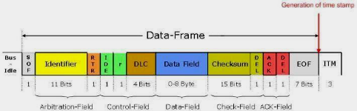

fig. 2.5 data frame

The intended

1. Remote frame

The intended purpose of the remote frame is to solicit the transmission of data from another node. The remote frame is similar to the data frame, with two important differences. First, this type of message is explicitly marked as a remote frame by a recessive RTR bit in the arbitration field, and secondly, there is no data.



Fig. 2.6 remote frame

1. Error Frame

The error frame is a special message that violates the formatting rules of a CAN message. It is transmitted when a node detects an error in a message, and causes all other nodes in the network to send an error frame as well. The original transmitter then automatically retransmits the message. An elaborate system of error counters in the CAN controller ensures that a node cannot tie up a bus by repeatedly transmitting error frames.



Fig 2.7 error frame

1. Overload frame

The overload frame is mentioned for completeness. It is similar to the error frame with regard to the format, and it is transmitted by a node that becomes too busy. It is primarily used to provide for an extra delay between messages.



Fig.2.8. overload frame

**5] BUS arbitration**

The CAN communication protocol is a carrier-sense, multiple-access protocol with collision detection and arbitration on message priority (CSMA/CD+AMP). CSMA means that each node on a bus must wait for a prescribed period of inactivity before attempting to send a message. CD+AMP mean that collisions are resolved through a bit-wise arbitration, based on a pre-programmed priority of each message in the identifier field of a message. The higher priority identifier always wins bus access. That is, the last logic-high in the identifier keeps on transmitting because it is the highest priority.

Whenever the bus is free, any unit may start to transmit a message. If two or more units start transmitting messages at the same time, the bus access conflict is resolved by bit-wise arbitration using the Identifier. The mechanism of arbitration guarantees that neither information nor time is lost. If a data frame and a remote frame with the same identifier are initiated at the same time, the data frame prevails over the remote frame. During arbitration every transmitter compares the level of the bit transmitted with the level that is monitored on the bus. If these levels are equal the unit may continue to send. When a ‟recessive‟ level is sent and a ‟dominant‟ level is monitored, the unit has lost arbitration and must withdraw without sending one more bit.

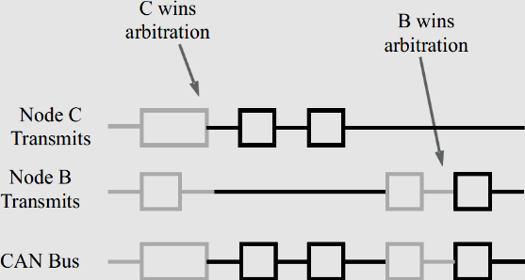

fig. 2.9. Bus arbitration

**3] Requirements**

**1] Hardware Requirements**

1.1] **STM32F407 Discovery Board**

The STM32F407xx family is based on the high-performance ARM® Cortex®-M4 32-bit RISC core with FPU operating at a frequency of up to 72 MHz, and embedding a floating point unit (FPU), a memory protection unit (MPU) and an embedded trace macro cell (ETM). The family incorporates high-speed embedded memories (up to 1 Mbytes of Flash memory, up to 192 Kbytes of RAM) and an extensive range of enhanced I/Os and peripherals connected to two APB buses.

They also feature standard and advanced communication interfaces: up to two I2Cs, up to three SPIs (two SPIs are with multiplexed full-duplex I2Ss), three USARTs, up to two UARTs, CAN and USB. To achieve audio class accuracy, the I2S peripherals can be clocked via an external PLL. The STM32F303xB/STM32F303xC family operates in the -40 to +85°C and -40 to +105 °C temperature ranges from a 2.0 to 3.6 V power supply. A comprehensive set of power-saving mode allows the design of low-power applications.



**1.2] LM35 temperature sensor**:

* A temperature sensor is used for sensing the temperature of the environment and the system displays the temperature on an lcd.
* The LM35 series are precision integrated temperature sensor.
* Features**-**

Calibrated Directly in Celsius (Centigrade)

* + Linear + 10-mV/°C Scale Factor
  + 0.5°C Ensured Accuracy (at 25°C)
  + Rated for Full -55°C to 150°C Range
  + Suitable for Remote Applications
  + Low-Cost Due to Wafer-Level Trimming
  + Operates From 4 V to 30 V
  + Less Than 60-μA Current Drain
  + Low Self-Heating, 0.08°C in Still Air
  + Non-Linearity Only ±¼°C Typical
  + Low-Impedance Output, 0.1 Ω for 1-mA Load

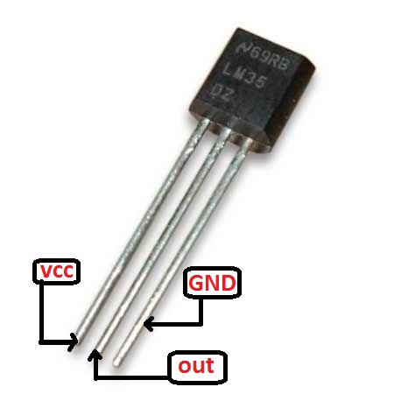

fig 1.2. LM35.

**1.3] HCSR04 Ultrasonic Sensor:**

* These sensors generate high frequency sound waves and calculate the time interval between sending the signal and receiving the echo to determine the distance to an object.
* Ultrasonic ranging module HC - SR04 provides 2cm - 400cm non-contact measurement function, the ranging accuracy can reach to 3mm. The modules includes ultrasonic transmitters, receiver and control circuit. The basic principle of work:

(1) Using IO trigger for at least 10us high level signal,

(2) The Module automatically sends eight 40 kHz and detect whether there is a pulse signal back.

(3) IF the signal back, through high level , time of high output IO duration is the time from sending ultrasonic to returning.

Test distance = (high level time ×velocity of sound (340M/S)) / 2.



Fig 1.3. Ultrasonic Sensor

**1.4] MQ3 Gas Sensor:**

1. Introduction

The MQ-3 is a semiconductor-based gas sensor designed for detecting alcohol vapors in the air. It is commonly used in breath analyzers, vehicle safety systems, and IoT-based alcohol monitoring applications.

2. Specifications

- *Operating Voltage:* 5V DC

- *Detection Range:* 0.04 mg/L to 4 mg/L (alcohol concentration)

- *Heater Consumption:* ≤ 750mW

- *Preheat Time:* ≥ 24 hours for stable operation

- *Sensitivity:* High sensitivity to alcohol and low sensitivity to benzine

- *Output Type:* Analog and Digital

3. Working Principle

The MQ-3 sensor consists of a *SnO₂ (Tin Dioxide) sensing element* that has a low conductivity in clean air. When alcohol vapors are present, they get oxidized on the heated surface, reducing the resistance and increasing conductivity. This change in resistance is converted into a proportional analog voltage, which can be read using an ADC (Analog-to-Digital Converter).

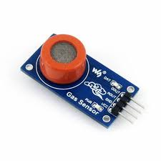

fig.1.4 MQ3 Gas Sensor

**1.5] I2C serial interface 20 x 4 LCD module :**

* This is I2C interface 20x4 LCD display module, a new high-quality 4 line 20 character LCD module with on-board contrast control adjustment, backlight and I2C communication interface.

Features :

* Display Type: Black on yellow green backlight. 20 x 4 display format .
* I2C Address:0x38-0x3F (0x3F default)
* Supply voltage: 5V
* Interface: I2C to 4bits LCD data and control lines.
* Contrast Adjustment : built-in Potentiometer.

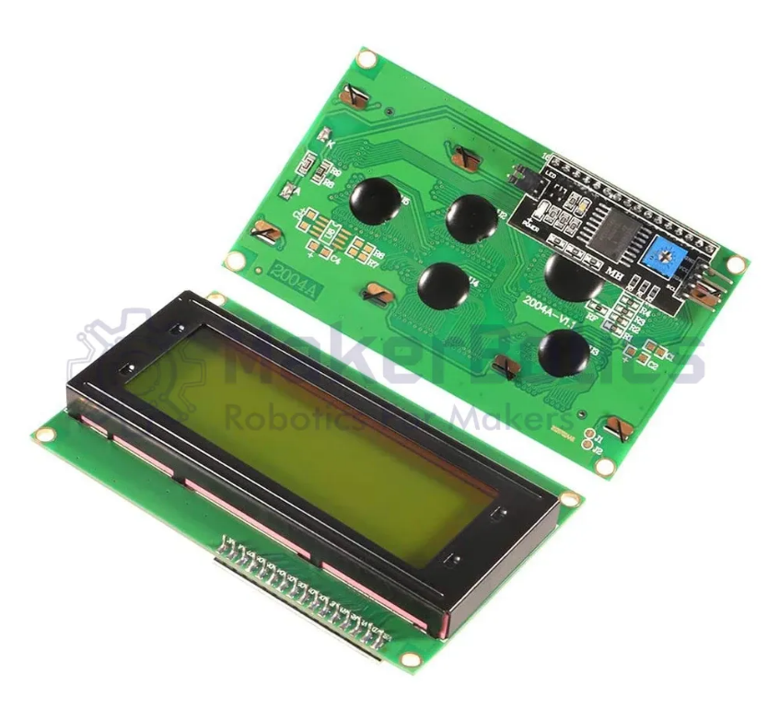

Fig .1.5. LCD display with I2C interface

**1.6] MCP2551(CAN transreceiver)**

• Implements ISO-11898 standard physical layer requirements

• Supports 1 Mb/s operation

• Suitable for 12V and 24V systems

• Externally-controlled slope for reduced RFI emissions

• Detection of ground fault (permanent dominant) on TXD input

• Power-on reset and voltage brown-out protection

• An unpowered node or brown-out event will not disturb the CAN bus

• Low current standby operation

• Protection against damage due to short-circuit conditions (positive or negative battery voltage)

• Protection against high-voltage transients

• Automatic thermal shutdown protection

• Up to 112 nodes can be connected

• High noise immunity due to differential bus implementation

• Temperature ranges: - Industrial (I): -40°C to +85°C - Extended (E): -40°C to +125°C

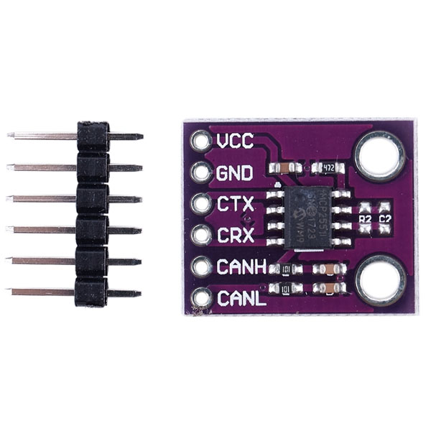

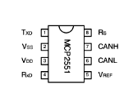

Fig.1.6 MCP2251 Module

**1.7] Buzzer**

This is an audio signaling device used at receivers side of system in this project.

Features :

* Diameter is 38mm Height is 22mm 2 Mounting holes distance:40mm 2 wires.
* rate voltage: 12v DC.
* operating voltage: 3 - 24v
* Buzzer type: piezoelectric sound pressure level 95

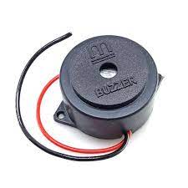

fig. 1.7. Buzzer

**2] Software Requirements**

**2.1] STM32CubeIDE**

STM32CubeIDE is an all-in-one multi-OS development tool, which is part of the STM32Cube software ecosystem.

STM32CubeIDE is an advanced C/C++ development platform with peripheral configuration, code generation, code compilation, and debug features for STM32 microcontrollers and microprocessors. It is based on the Eclipse®/CDT™ framework and GCC toolchain for the development, and GDB for the debugging. It allows the integration of the hundreds of existing plugins that complete the features of the Eclipse® IDE. STM32CubeIDE integrates STM32 configuration and project creation functionalities from STM32CubeMX to offer all-in-one tool experience and save installation and development time. After the selection of an empty STM32 MCU or MPU, or preconfigured microcontroller or microprocessor from the selection of a board or the selection of an example, the project is created and initialization code generated..

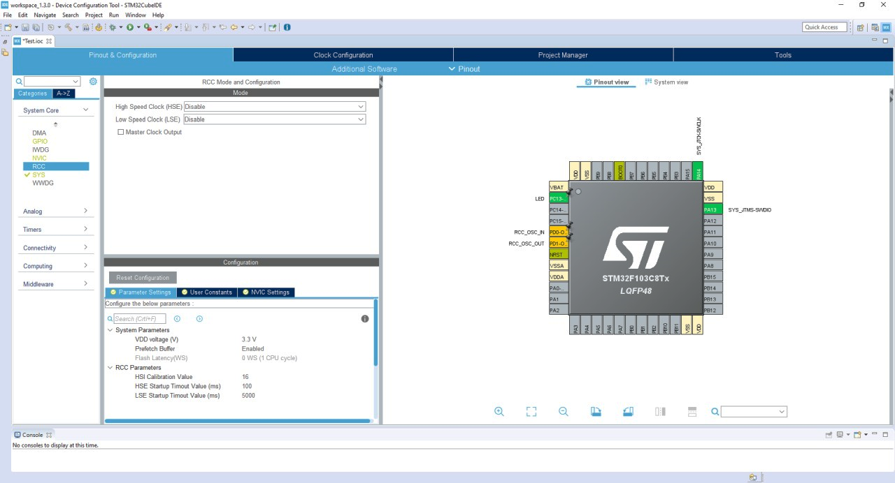fig 2.1. STM32 cube IDE interface

At any time during the development, the user can return to the initialization and configuration of the peripherals or middleware and regenerate the initialization code with no impact on the user code.

STM32CubeIDE includes build and stack analysers that provide the user with useful information about project status and memory requirements. STM32CubeIDE also includes standard and advanced debugging features including views of CPU core registers, memories, and peripheral registers, as well as live variable watch, Serial Wire Viewer interface, or fault analyser.

**Features :**

* Integration of services from STM32CubeMX:STM32 microcontroller, microprocessor, development platform and example project selection Pinout, clock, peripheral, and middleware configuration Project creation and generation of the initialization code Software and middleware completed with enhanced STM32Cube Expansion Packages.
* Based on Eclipse®/CDT™, with support for Eclipse® add-ons, GNU C/C++ for Arm® toolchain and GDB debugger
* STM32MP1 Series: Support for Open ST Linux projects: LinuxSupport for Linux
* Additional advanced debug features including:CPU core, peripheral register, and memory viewsLive variable watch viewSystem analysis and real-time tracing (SWV)CPU fault analysis tool RTOS-aware debug support including Azure.
* Support for ST-LINK (STMicroelectronics) and J-Link (SEGGER) debug probes
* Multi-OS support: Windows®, Linux®, and macOS®, 64-bit versions only

**4] Project Architecture And Flowchart**

**4.1] Block Diagram**

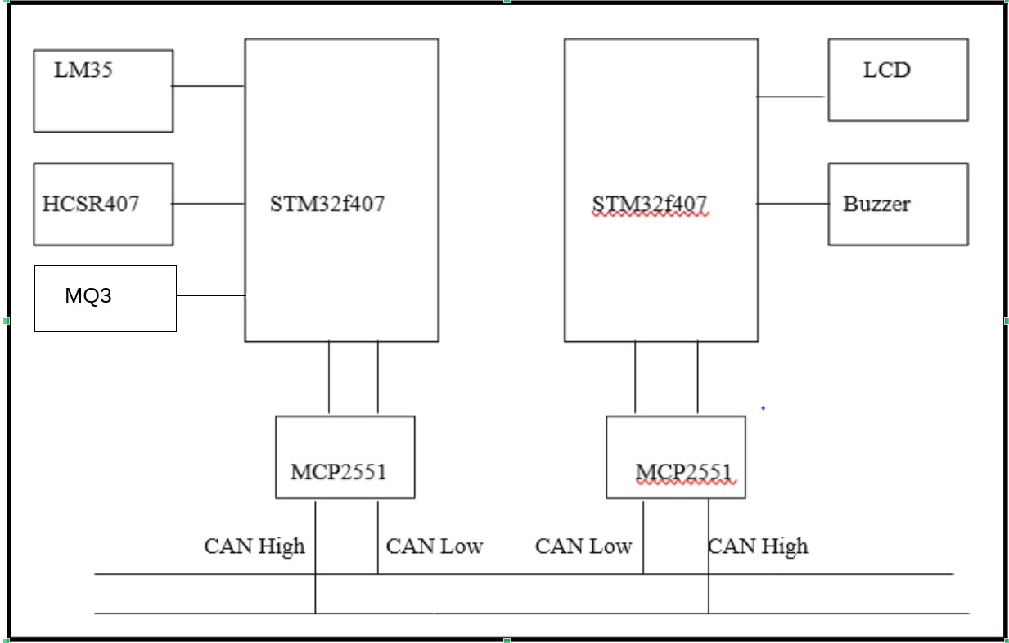

**4.2] Description**

As per the block diagram, this system uses two STM32F407 Discovery Boards, one as a transmitter and the other as a receiver.

It utilizes a temperature sensor (LM35) to detect engine heat, an ultrasonic sensor (HC-SR04) to measure the speed and distance of objects/vehicles, and an MQ-3 gas sensor to detect alcohol concentration in the driver’s breath. These sensors are interfaced with the STM32F407 microcontroller for real-time data acquisition.

On the transmitting end, the STM32F407 microcontroller collects data from the temperature sensor, ultrasonic sensor, and MQ-3 gas sensor. This data is then transmitted to the receiver’s end via the Controller Area Network (CAN) protocol.

### System Communication and Connections:

This system uses the CAN protocol for communication between the sensors and the display/alert system at the receiver end. The driver alert system consists of transmitting and receiving units:

#### Transmitter End:

* STM32F407 Discovery Board: Inbuilt CAN module for data transmission.
* MCP2551 Transceiver: Handles CAN communication.
* LM35 (Temperature Sensor): Connected to A0 pin to measure temperature.
* Ultrasonic Sensor (HC-SR04):
  + Trigger Pin: Connected to PA0.
  + Echo Pin: Connected to PA1.
* MQ-3 Gas Sensor: Connected to an ADC pin to measure alcohol concentration.
* CAN Connections:
  + PB9 (CAN TX) → MCP2551 TX
  + PB8 (CAN RX) → MCP2551 RX
* CAN Bus Wiring: Both transceivers (MCP2551) are interconnected using CAN High (CANH) and CAN Low (CANL) lines.

#### Receiver End:

* LCD Display (I2C Module):
  + SCL (Clock) Pin: Connected to PB6.
  + SDA (Data) Pin: Connected to PB7.
* Buzzer Alert:
  + PB14 is used as the output pin for the buzzer.
* Data Processing:
  + The received temperature, distance, and alcohol concentration values are continuously displayed on an LCD screen.
  + If temperature exceeds 60°C, an obstacle is detected at a close distance, or alcohol concentration crosses a predefined threshold, the buzzer is activated to alert the driver.

This system ensures real-time monitoring and alert generation for improved driver safety.

**Flowchart :**

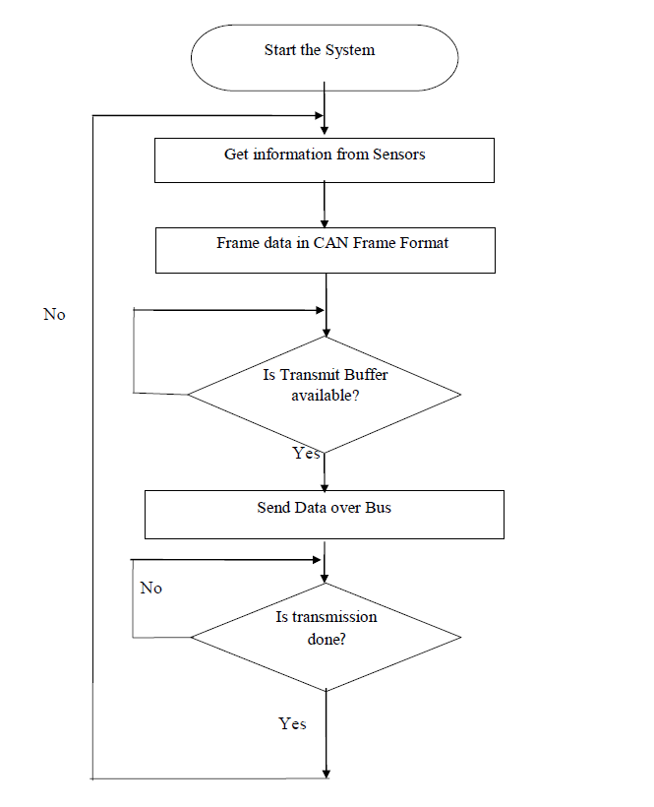

**F**ig . 4.3 Node A flowchart

**5] Source Code Explanation**

**5.1]** **transmitter node source code** :

#define TRIG_PIN GPIO_PIN_11

#define TRIG_PORT GPIOE

uint32_t Value1 = 0;

uint32_t Value2 = 0;

uint8_t Distance  = 0;

* We have defined input output pins for trigger and echo port of ultrasonic module. Some variables for further calculations have initialized.

uint8_t LM35;

volatile int Switch_Flag = 0;

CAN_TxHeaderTypeDef TxHeader;

uint8_t TxData[5];

uint32_t TxMailBox;

* Data frame of 8 bit for transmitting through CAN protocol is declared . we have declared 32 bit mailbox of CAN frame to transmit over bus.

HAL_CAN_Start(&hcan1);

  HAL_CAN_ActivateNotification(&hcan1, CAN_IT_RX_FIFO0_MSG_PENDING);

  HAL_Delay(100);

  HAL_Delay(100);

  TxHeader.DLC=3;

  TxHeader.RTR=CAN_RTR_DATA;

  TxHeader.IDE=CAN_ID_STD;

  TxHeader.ExtId=0x0;

  TxHeader.StdId=0x0AA;

  TxHeader.TransmitGlobalTime=DISABLE;

  TxData[0] = 0;

  HAL_TIM_IC_Start_IT(&htim1, TIM_CHANNEL_1);

* CAN is activated for RX_FIFO notification, transmission data length is been set to 3, RTR bit indicating data transmission . IDE indicating standard (11 bit frame ) and standard id is defined.
* void HAL_TIM_IC_CaptureCallback(TIM_HandleTypeDef *htim)
* {
* if (htim->Channel == HAL_TIM_ACTIVE_CHANNEL_1) // if the interrupt source is channel1
* {
* if (Is_First_Captured==0) // if the first value is not captured
* {
* IC_Val1 = HAL_TIM_ReadCapturedValue(htim, TIM_CHANNEL_1); // read the first value
* Is_First_Captured = 1; // set the first captured as true
* // Now change the polarity to falling edge
* __HAL_TIM_SET_CAPTUREPOLARITY(htim, TIM_CHANNEL_1, TIM_INPUTCHANNELPOLARITY_FALLING);
* }
* else if (Is_First_Captured==1) // if the first is already captured
* {
* IC_Val2 = HAL_TIM_ReadCapturedValue(htim, TIM_CHANNEL_1); // read second value
* __HAL_TIM_SET_COUNTER(htim, 0); // reset the counter
* if (IC_Val2 > IC_Val1)
* {
* Difference = IC_Val2-IC_Val1;
* }
* else if (IC_Val1 > IC_Val2)
* {
* Difference = (0xffff - IC_Val1) + IC_Val2;
* }
* Distance = Difference * .034/2;
* Is_First_Captured = 0; // set it back to false
* // set polarity to rising edge
* __HAL_TIM_SET_CAPTUREPOLARITY(htim, TIM_CHANNEL_1, TIM_INPUTCHANNELPOLARITY_RISING);
* __HAL_TIM_DISABLE_IT(&htim1, TIM_IT_CC1);
* }
* }
* }
* For distance calculation Trigger pin and echo Pin of ultrasonic sensor being modified in above code . Finally distance is calculated using formula with values of high and low echo wave detection.
* ADC Count for LM35 readings assigned to corresponding LM35 variable using HAL_ADC_GetValue() function.

v HAL_ADC_Start(&hadc1);//PA2

HAL_ADC_PollForConversion(&hadc1, HAL_MAX_DELAY);

LM35 = HAL_ADC_GetValue(&hadc1) / 12 ; //divided by 12 bcoz 10mv=1degreeCel. in LM 35

HAL_ADC_Stop(&hadc1);

* This is another alternate function to get exact value of temperature by converting ADC counts to temperature.
* TxData[0] = !TxData[0]; //LED
* TxData[1] = LM35;
* TxData[2] = Distance;
* if (HAL_CAN_AddTxMessage(&hcan1, &TxHeader, TxData, &TxMailBox) != HAL_OK)
* Error_Handler();
* HAL_GPIO_TogglePin(GPIOD, GPIO_PIN_12);
* HAL_Delay(500);
* We used LED as successful data transmission indication at receiver side it will turn on the LED
* We are sending distance and temperature data through mailbox attaching it to TxHeader declared above .

CAN_FilterTypeDef canFilterConfig;

  canfilterconfig.FilterActivation = CAN_FILTER_ENABLE;

canfilterconfig.FilterBank = 2;

canfilterconfig.FilterFIFOAssignment = CAN_FILTER_FIFO0;

canfilterconfig.FilterIdHigh = 0x103<<5;

canfilterconfig.FilterIdLow = 0;

canfilterconfig.FilterMode = CAN_FILTERMODE_IDMASK;

canfilterconfig.FilterMaskIdHigh = 0x103<<5;

canfilterconfig.FilterMaskIdLow = 0x0000;

canfilterconfig.FilterScale = CAN_FILTERSCALE_32BIT;

canfilterconfig.SlaveStartFilterBank = 14;

HAL_CAN_ConfigFilter(&hcan1, &canfilterconfig);

* We have configured CAN filters for data transmission filteration. These filter configuration will help to avoid unnecessary data transmission and save data space.

**5.2]** **Receiver node source code**

CAN_RxHeaderTypeDef RxHeader;

uint8_t RxData[3];

char str[20];

void HAL_CAN_RxFifo0MsgPendingCallback(CAN_HandleTypeDef *hcan){

  HAL_GPIO_WritePin(GPIOD, GPIO_PIN_15, GPIO_PIN_SET); // blue

  HAL_CAN_GetRxMessage(&hcan1, CAN_RX_FIFO0, &RxHeader, RxData);

* Declared Rx data buffer to receive messages and a string ‘str ’ to display messages on lcd.
* Collected messages in Rxdata with Rxdata header ID and enabled data collection for Rx fifo filter configuration
* HAL_CAN_Start(&hcan1);
* HAL_CAN_ActivateNotification(&hcan1, CAN_IT_RX_FIFO0_MSG_PENDING);
* HAL_Delay(100);
* HAL_Delay(100);
* lcd_init();
* Initialized lcd and CAN to notify on indication of RX_fifo_message_pending ; so it can receive the message passed through filter.
* while (1)
* {
* sprintf(str, "Temp:%d",RxData[1]);
* lcd_send_cmd(0x80|0x00);
* lcd_send_string(str);
* sprintf(str, "Alc:%d",RxData[2]);
* lcd_send_cmd(0x80|0x40);
* lcd_send_string(str);
* if(RxData[0] == 1){
* HAL_GPIO_WritePin(GPIOD, GPIO_PIN_14, GPIO_PIN_SET); //
* }
* if(RxData[0] == 0){
* HAL_GPIO_WritePin(GPIOD, GPIO_PIN_14, GPIO_PIN_RESET); //
* }
* Used a infinite while loop for data reception. Accepted temperature data and displayed it to line one of lcd as ‘str’ value. Similarly displayed distance data on line two of lcd.

**6] Testing images**

**6.1] Connections**

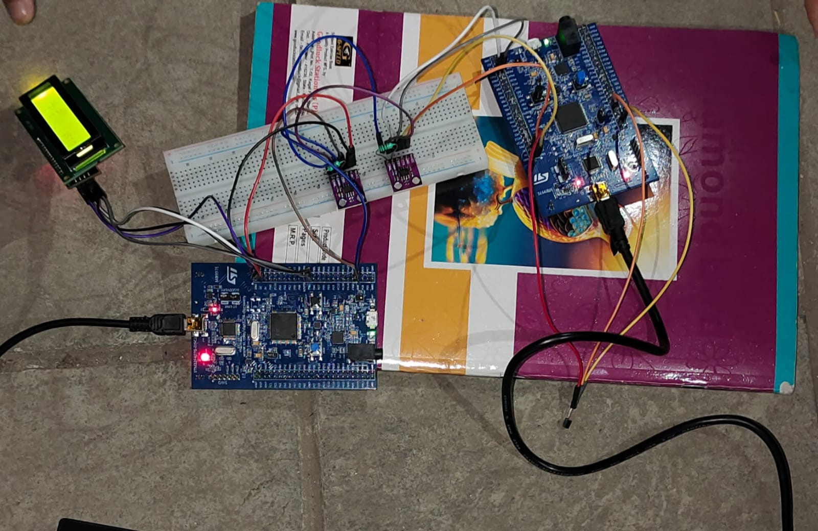

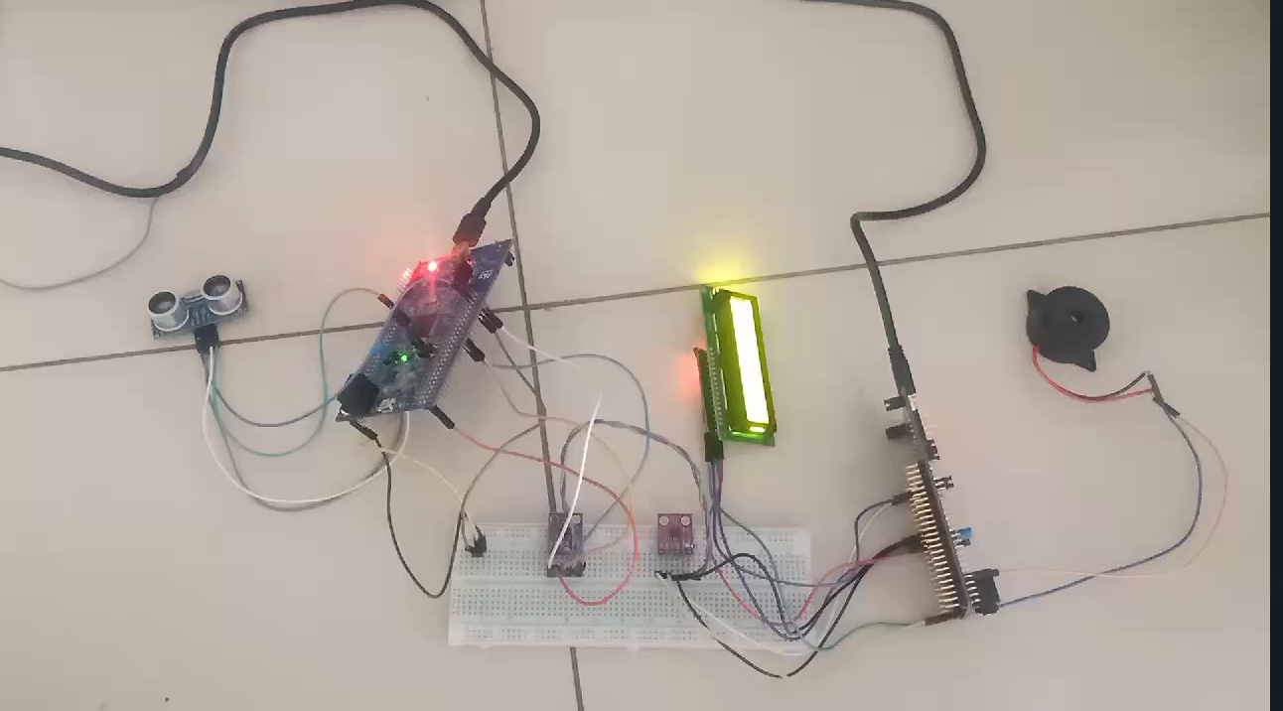

**6.2] Result**

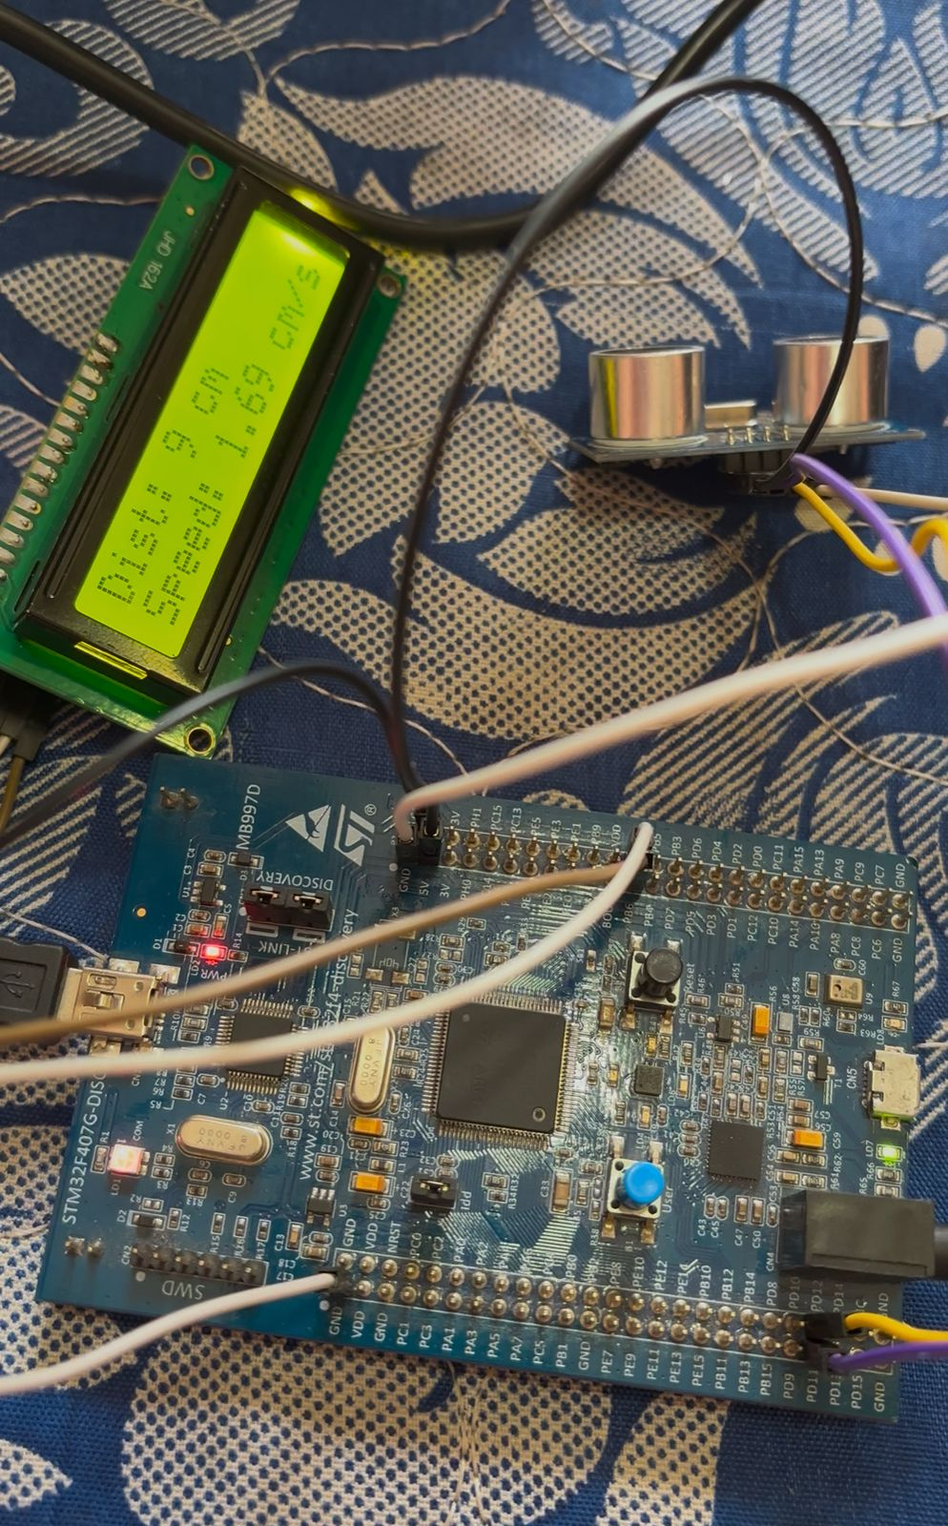

**7] Conclusion**

* The Smart Vehicle Telematics System using CAN successfully integrates multiple sensors with STM32F407 microcontrollers to enhance vehicle safety and monitoring. By utilizing the Controller Area Network (CAN) protocol, the system ensures efficient and reliable communication between the transmitter and receiver units, enabling real-time data transmission.
* The system continuously monitors critical vehicle parameters, including engine temperature (LM35 sensor), obstacle distance (Ultrasonic sensor - HC-SR04), and alcohol concentration (MQ-3 sensor). The collected data is displayed on an LCD screen, and if predefined thresholds are exceeded, an alert mechanism (buzzer) is triggered to notify the driver.
* This implementation demonstrates the effectiveness of CAN-based communication in modern automotive applications, providing a robust and scalable solution for driver assistance systems. The system can be further enhanced by integrating GPS, GSM, and AI-based decision-making algorithms for advanced vehicle telematics and accident prevention.
* Overall, this project contributes to road safety, driver assistance, and vehicle monitoring, making it a valuable solution for smart transportation systems.

**8] Future Scope**

We successfully implemented a system working on the CAN protocol that can detect and provide respective alerts to prevent excessive heating of the car and measure the distance between obstacles and the vehicle. This has been implemented using a temperature sensor (LM35), an ultrasonic sensor (HC-SR04), and an alcohol detection sensor (MQ-3), all interfaced with the STM32F407 microcontroller. These sensors are mounted on one STM32F407 board, which communicates with another STM32F407 board over CAN. The collected sensor data is displayed on an LCD screen mounted on the receiver hardware.

Additionally, the MQ-3 alcohol sensor detects the presence of alcohol in the driver’s breath. If the alcohol concentration exceeds a predefined limit, the system triggers an alert via a buzzer, ensuring driver safety by preventing drunk driving.

### Future Enhancements:

* Remote System Control – The system can be expanded to allow remote control of vehicle functions (e.g., turning on the AC, activating the buzzer, rolling windows) based on sensor data.
* Cloud Connectivity using IoT – The collected sensor data can be uploaded to the cloud using IoT protocols like MQTT, enabling remote monitoring and data analysis.
* Industry Applications – A similar system has been used by TATA Motors for remote AC control, showcasing its potential in modern vehicles.

These enhancements will further improve vehicle automation, safety, and driver assistance, making it a smart telematics solution

### **References**

1. Robert Bosch GmbH, “CAN Specification Version 2.0,” 1991.
2. Texas Instruments, “Understanding and Using the Controller Area Network (CAN),” Application Report, 2016.
3. STMicroelectronics, “STM32F407 Reference Manual,” RM0090, 2018.
4. MCP2551 Datasheet, Microchip Technology Inc., 2015.
5. LM35 Temperature Sensor Datasheet, Texas Instruments.
6. HC-SR04 Ultrasonic Sensor Datasheet, Cytron Technologies.
7. MQ-3 Gas Sensor Datasheet, Hanwei Electronics.
8. TATA Motors Telematics Systems, Official Website & Technical Reports.
9. IoT Protocols and Applications, MQTT.org – MQTT Technical Documentation.
10. Research papers and IEEE articles on CAN-based vehicle communication and safety systems.